**WT-SFP-1310**

* 1. Gbps SFP Optical Transceiver, 10km Reach

# Features

* + - Dual data-rate of 1.25Gbps/1.063Gbps operation
    - 1310nm FP laser and PIN photodetector for 20km transmission
    - Compliant with SFP MSA and SFF-8472 with duplex LC receptacle
    - Digital Diagnostic Monitoring:
    - Internal Calibration or External Calibration

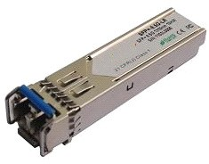

* + - Compatible with SONET OC-24-LR-1
    - Compatible with RoHS

➢ +3.3V single power supply

* + - Operating case temperature:
    - Standard : 0 to +70°C
    - Industrial : -40 to +85°C

# Applications

* + - Gigabit Ethernet
    - Fiber Channel
    - Switch to Switch interface
    - Switched backplane applications
    - Router/Server interface
    - Other optical transmission systems

# Description

* + - The SFP transceivers are high performance, cost effective modules supporting dual data-rate of 1.25Gbps/1.0625Gbps and 20km transmission distance with SMF.
    - The transceiver consists of three sections: a FP laser transmitter, a PIN photodiode integrated with a trans-impedance preamplifier (TIA) and MCU control unit. All modules satisfy class I laser safety requirements.
    - The transceivers are compatible with SFP Multi-Source Agreement (MSA) and SFF-8472.

